Home (Landing Page)
├── Research & Students
├── Publications
├── Teaching
├── Projects / Systems
├── Service & Leadership
├── Honors, Awards & Media
├── Talks / Presentations
└── Contact

This mirrors the structure most academic websites use to organize information clearly. (theacademicdesigner.com)

1. Home / Main (Landing Page – Current Page to Be Redesigned)
A. Overall Design Goals
- Modern, minimalist, research-focused design
- Fast loading (optimized images, lightweight framework, clean code)
- Fully responsive (desktop, tablet, mobile)
- SEO-optimized structure
- Easy future content updates (CMS-based or admin-editable sections)
B. Navigation Bar (Top Fixed Navigation)
A clean navigation bar should appear at the top of the page, preferably fixed (sticky) while scrolling.
Navigation Menu:
Home | Research & Students | Publications | Teaching | Project/Lab | Services | Contact
Navigation Behavior
When a user clicks a menu item:
- Option 1: Smooth-scroll to the corresponding section within the same page (single-page design), or
- Option 2: Open a dedicated subpage in a new page/tab layout.
The final decision can be based on performance and usability preferences.

C. Landing Page Visual Identity
The background design of the landing page should reflect my core research areas:
- Cybersecurity
- Trustworthy AI / Machine Learning
- Wireless Sensing (e.g., Wi-Fi CSI–based sensing)
- Secure and dependable systems
Visual Suggestions
- Subtle network grid or encrypted-code motif
- Abstract wireless signal waves
- AI/neural-network style geometric patterns
- Dark-blue / tech-inspired color palette with professional contrast
The design should remain elegant and subtle — not overly decorative. Visual elements must not slow page performance.

D. Page Header Section (Hero Section)
The top section should include:
- Title / Tagline. Example format:
“Professor Zakirul Alam Bhuiyan - Computer Science — Cybersecurity & Trustworthy AI/ML”
This should appear prominently and professionally styled.
- Professional Photo [Positioned either left or right of the header text, Circular or soft-rectangle framing]
- Highlight / News Box

E. Page details (I will provide later)

About Him/Bio
xxxx
Short Bio.
xxx

2. Research & Students
DependSys Lab
details

Research Interest
- Cybersecurity & Privacy | Data-Driven Dependability
- Trustworthy AI / Machine Learning
- Wireless Sensing & Authentication
- Data Mining & Behavioral Modeling
- Applied Machine Learning for Security, Systems & HCI
- Post-Quantum Cryptography (PQC) y | Secure Quantum Machine Learning (SQML)
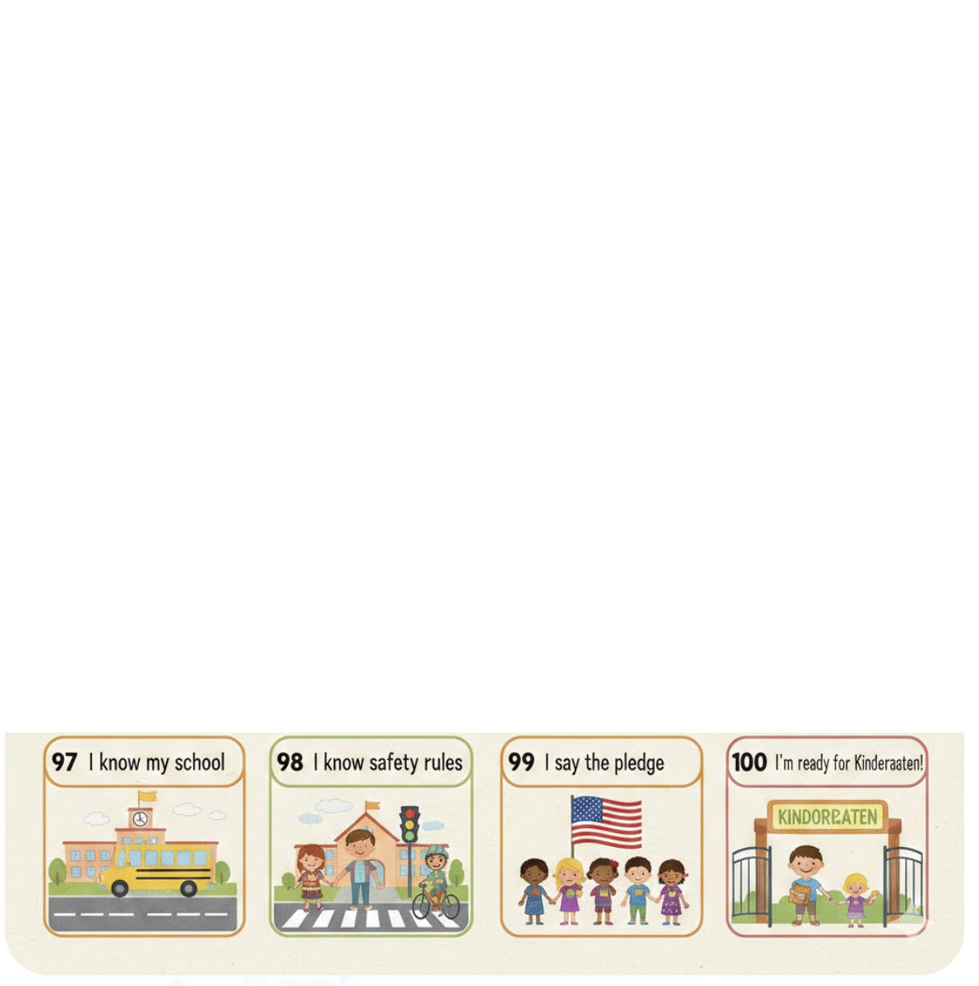Research Overview

PhD/MS Position Availability

Ongoing Projects
- Details with 1-2 Images

Students
PhD Students
Co-supervising:
Student Graduated
Graduated

5. Project & Lab
DependSys Lab
details

Overview of Project Works
xx
Cybersecurity & Privacy

Trustworthy AI / ML

Wireless Sensing (Wi-Fi CSI)

IoT / CPS Security

Post-Quantum Security & QML

Lab Photos

Posters/Demos

3. Publications
Publication Overview
Xxx xxx xxx xxx
Publications by Topics [Click each topic to see the list]
Cybersecurity & Privacy, IoT / CPS Security  Trustworthy AI / ML  Authentications  Wireless Sensing (Wi-Fi CSI)  Post-Quantum Security & QML | - Author names, “Titles,” Journal/transaction Name, Vol. X (No. X): PageX-PageY, Year. [Any Comment]  - X  - X

Publications in Journals/transactions
- Author names, “Publication Titles,” Journal/transaction Name, Vol. X (No. X): PageX-PageY, Year. [Any Comment]
Publications in Conferences
- Author names, “Titles”, Conference Name/title, Vol. X (No. X): PageX-PageY, Year. [Any Comment]
Book
Magazine

4. Teaching
Course Taught/teaching
Cybersecurity & Privacy
- X
- X
Data Science and Security

Core CS courses

- Teaching philosophy
- Student resources (links to files on Canvas, Google Drive, etc.)

6. Service & Leadership
Department
- Associate Chair | Director of Undergraduate Studies (RH)
  - Associate Chair Duties
- Associate Chair (Key roll) | Director of Undergraduate Studies (LC)
Committee
Conference Service
Conference Service
Editorial Boards
Outreach

7. Opening >> Open Position
Full Funded PhD Studentship by University
Dept Faculty Position
Any MS/Undergrads Research Opportunities
Voluntary MS/Undergrads Research Opportunities
If you are interest in any of the opportunities, please send your interest by this form: Contact

6. Contact
Please Optional contact form [Compose Form: Name, Email, Subject, Content xx]
Sender:
Name | □
Subject | □
Content | □
Email | □
Submit

- Office Address
Xx
xx
- Social links
LinkedIn, Google Scholar, Twitter, GitHub etc.

